EXPERIMENT 4 —Step-wise Solution

PART A: LOAD DATA AND BUILD REPORT
Step 1: Open the Power BI Model
We opened the Power BI model created in Experiment 3 and verified that the required tables and relationships were available. We then prepared visuals for Sales by Region, Profit by Category, Sales by Segment, and Sales Trend by Year.
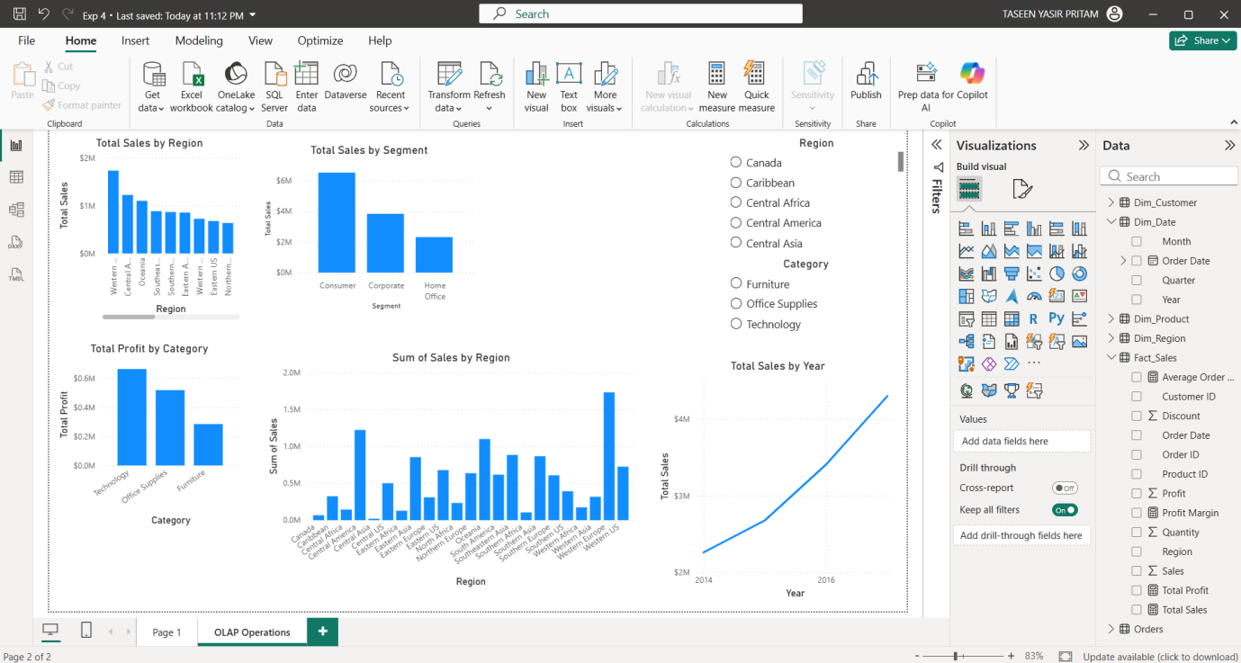

PART B: SLICE OPERATION
Step 2: Apply a Slice
A Region slicer was added to the report. We selected one region, such as Western Europe, and observed how the Sales, Profit, and Order values changed based on the selected region.
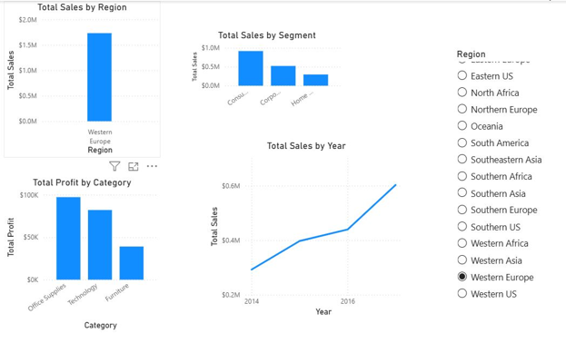
PART C: DICE OPERATION
Step 3: Apply Multiple Filters
Multiple filters were applied at the same time to perform a Dice operation. For example, we selected:
- Region = Western Europe
- Category = Technology
- Year = 2017
The resulting Sales, Profit, and Orders were analyzed for this specific combination.
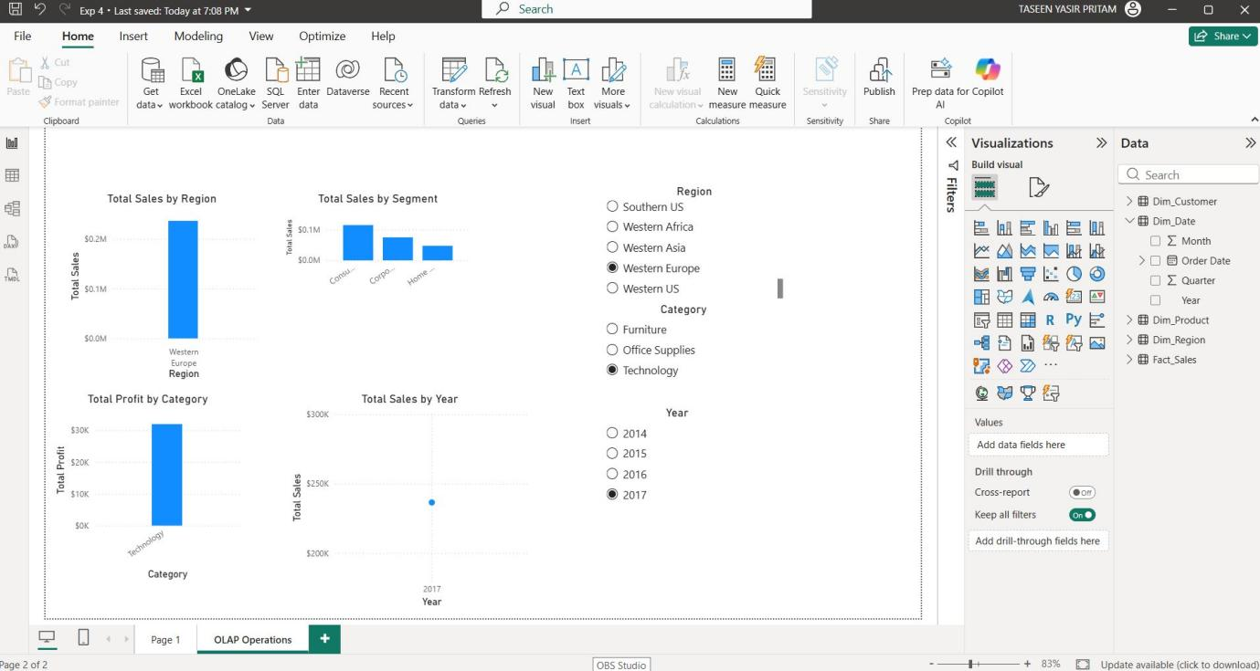
PART D: DRILL-DOWN OPERATION
Step 4: Analyze Data at Different Levels
A hierarchy was created using Region → State → City. The visual was then used in Drill-down mode to move from the regional level to individual states and cities.
This allowed us to examine sales performance in greater detail.
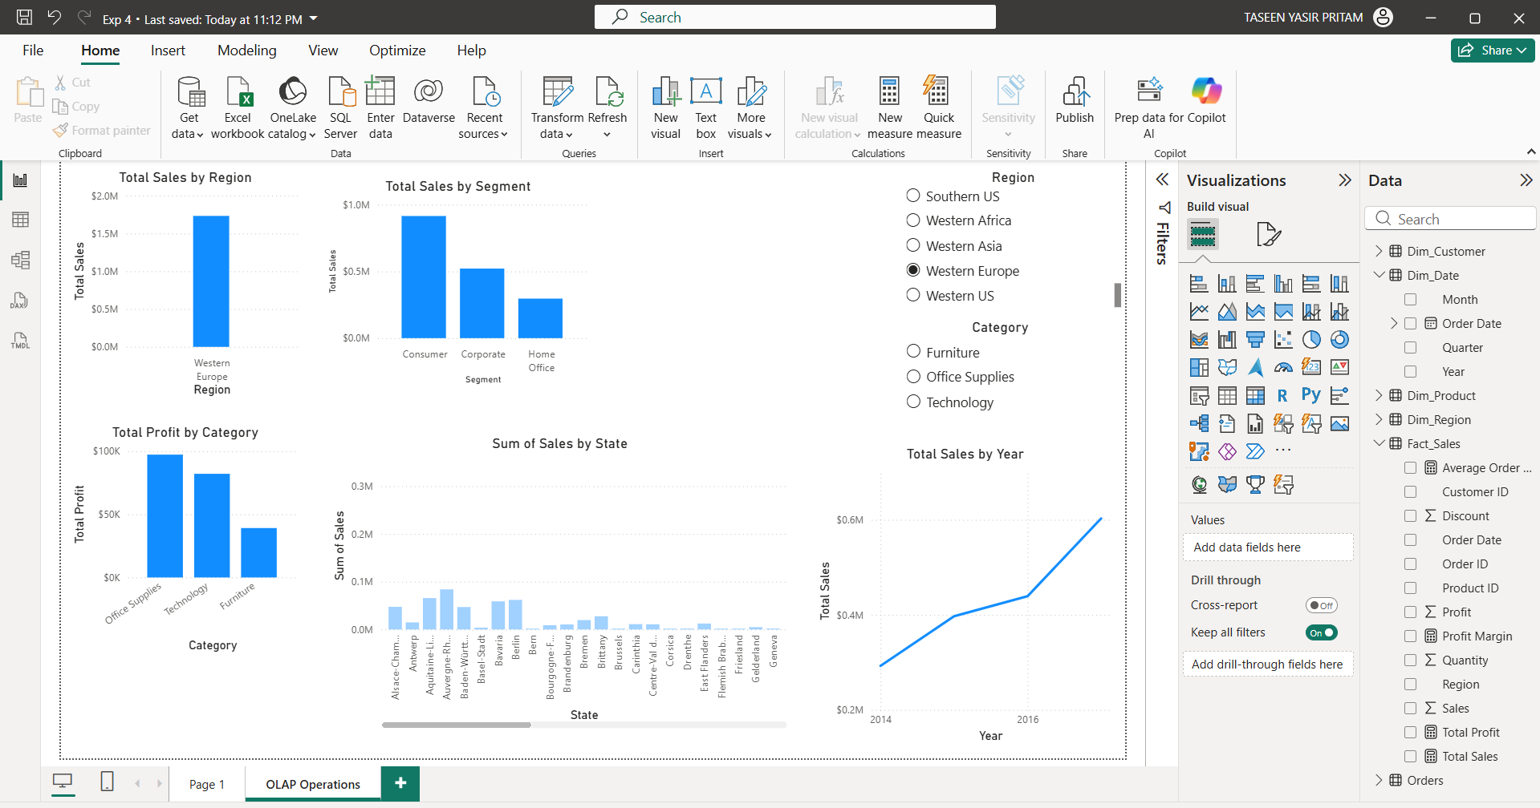

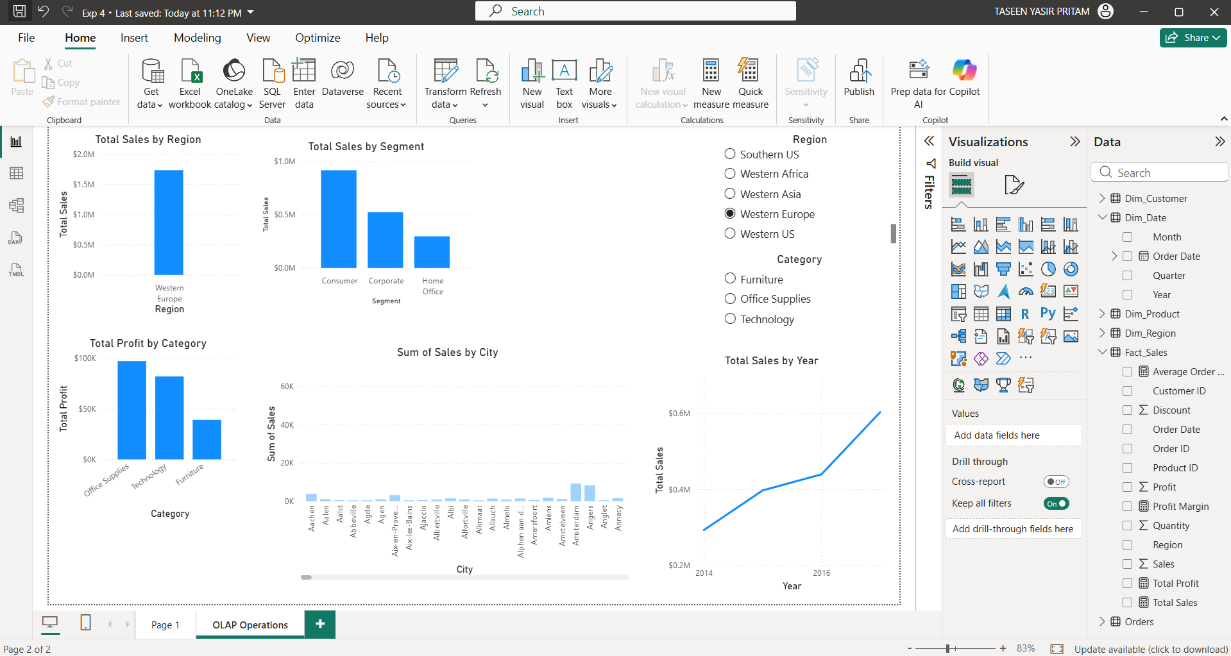

PART E: DRILL-UP OPERATION
Step 5: Return to Higher-Level Data
After analyzing the city-level information, we used Drill-up to move back from City → State → Region. The aggregated values at each level were compared to understand the overall business performance.
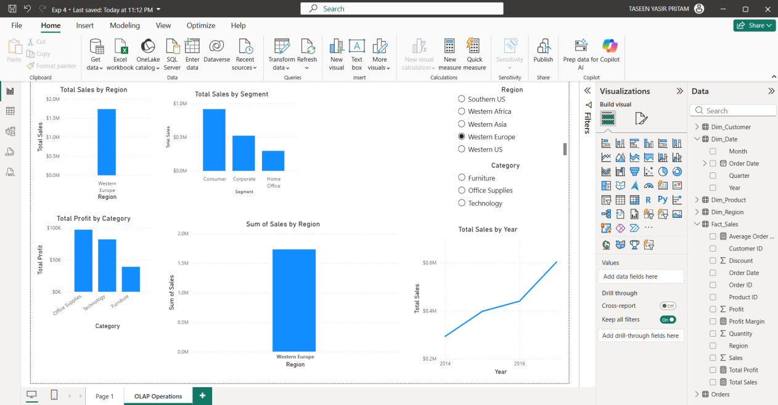

PART F: OLAP ANALYSIS
Step 6: Compare OLAP Operations
The results from Slice, Dice, Drill-down, and Drill-up were compared to understand how each operation provides a different view of the same business data.
A summary of the observations was prepared to show how these operations can support business decision-making.

